Ontario Natural Building Coalition
Natural Building Conference – April 4 and 5, 2020
Conference Presenters

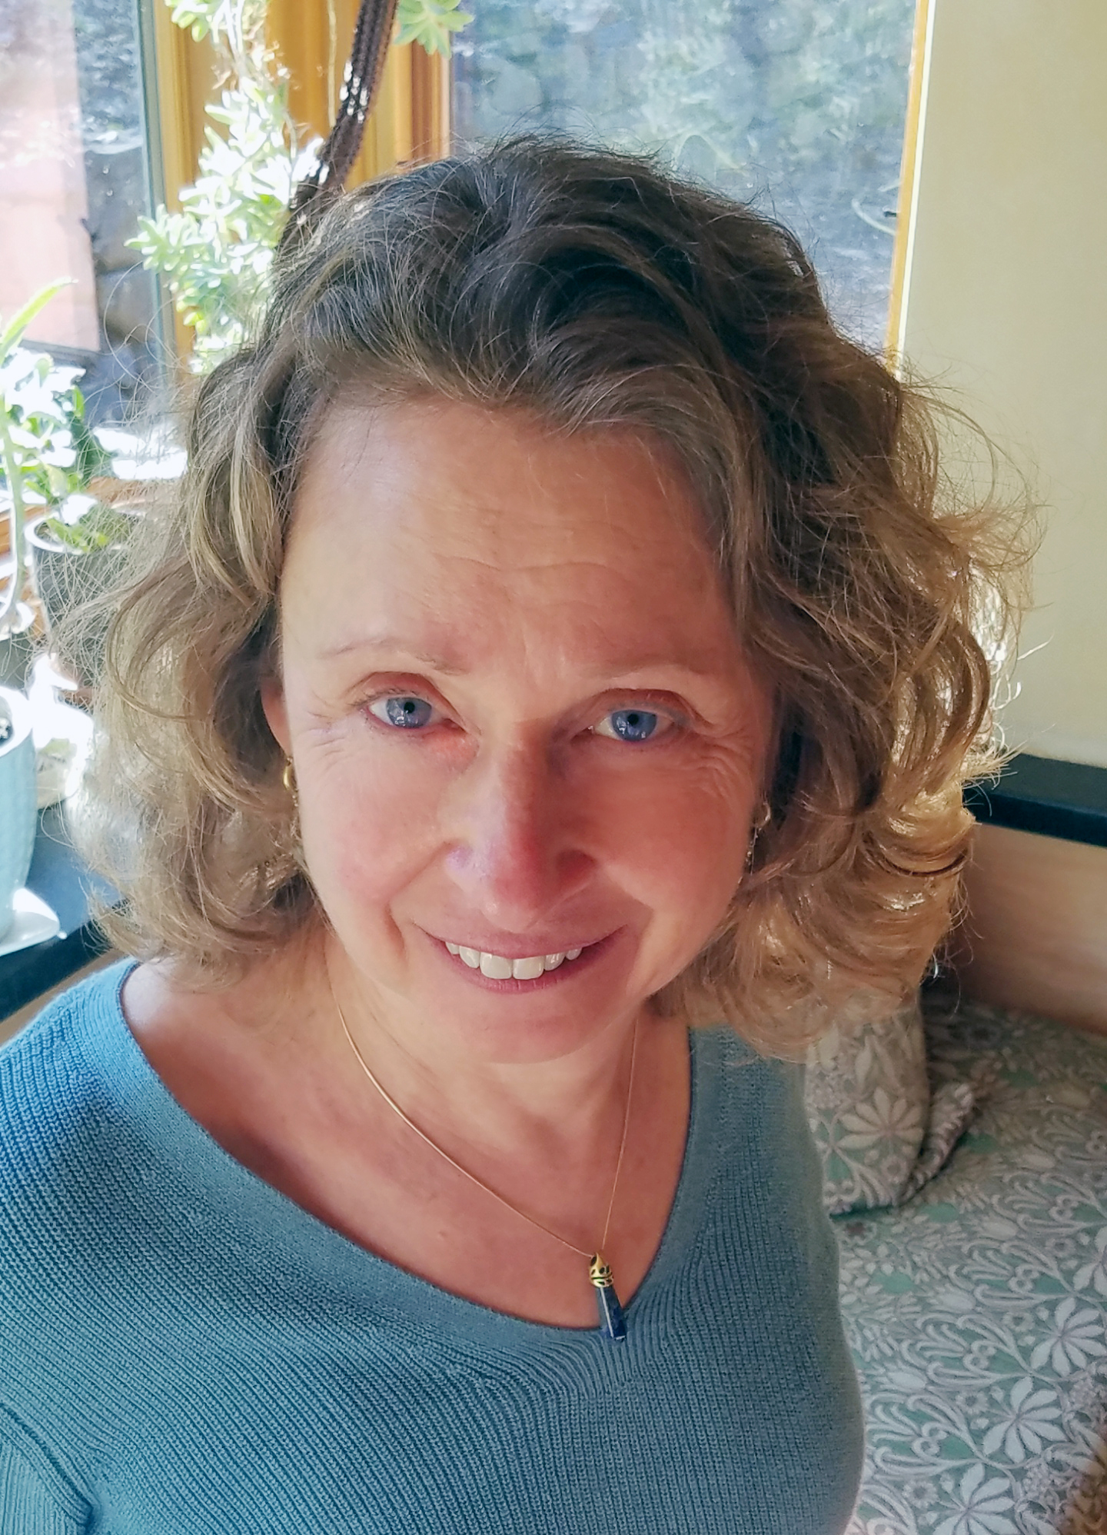
Paula Baker-Laporte FAIA, BBNC

Paula is a Fellow of the American Institute of Architects and a certified Building Biologist. Her architectural practice is focused on the creation of environmentally sound and health enhancing architecture working with traditional, nature-based building systems. Paula also serves as a consultant on the health aspects of building throughout North America. She has been an instructor for the Building Biology Institute since 2006. Her published books include “Prescriptions for a Healthy House”, now in its third (soon to be 4th) edition and two books about her architectural work with husband and co-author Robert Laporte: “EcoNest.-Creating Sustainable Sanctuaries of Clay and Timber(2007)” and “The EcoNest Home”(2015)

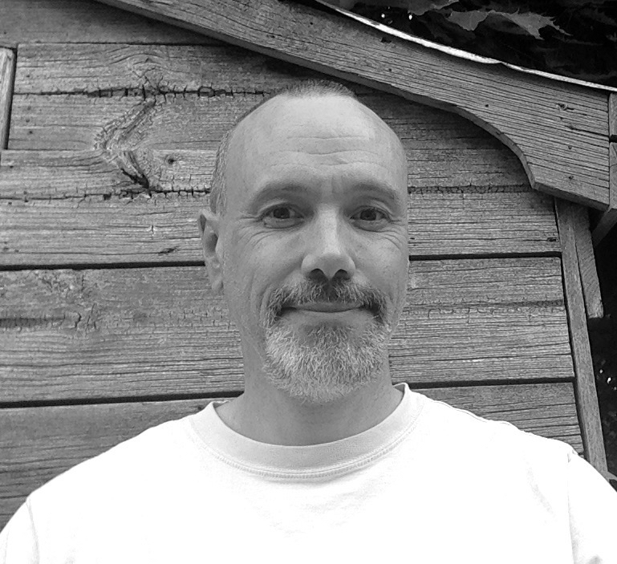
Matt Adams

In 2007 Matt was a co-founder of the Fourth Pig worker co-op and is the Fourth Pig Operations and Education Director. For over thirty years Matt has worked in non-profits in a variety of capacities, including in education, communications and business administration. He has a Masters Degree in Sociology and Equity Studies (Adult Education) from OISE/University of Toronto. He is the co-author of two adult education text books. He is a PHIUS Certified Builder.

Matt was the program director for a national literacy program in the U.S., he co-founded a popular education co-op in Toronto where he designed curricula and delivered trainings and workshops to many non-profits. He was also part of a community based research team exploring the social determinants of health. For many years he was a senior staff member at rabble.ca, Canada's most read independent news source and worked as the publicist for a long-running art festival and an independent press.

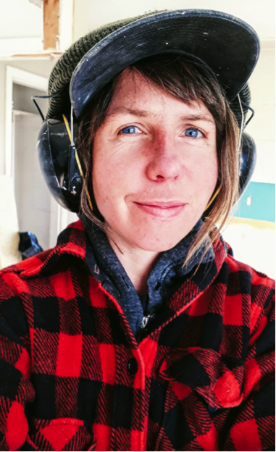
Annie Murphy
Annie Murphy is a builder and educator based in Halifax, Nova Scotia. Annie’s interest in building was sparked after spending a few winters in a beautiful but frigid stone house in Ottawa, Ontario. After studying sustainable building through the Endeavour Centre in Peterborough, Canada, she has gone on to work for design/build companies from Ontario to the East Coast of Canada where she now resides. From natural, green and high efficiency projects, she has developed a skill set specific to the demands of sustainable building in a northern climate.
Her passion for education has lead her to direct and instruct both the Endeavour Centre’s Natural Building Intensive and YM Design/Build School’s Natural Building Certificate, where she’s taught construction skills with an emphasis on social justice and sustainability, and always with a healthy dose of humour!

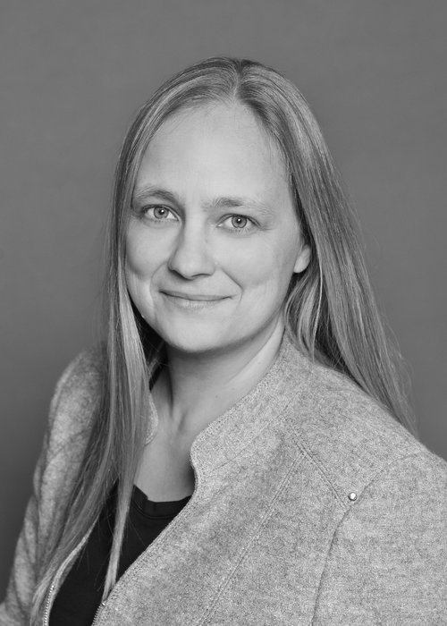
Melinda Zytaruk

Melinda Zytaruk, General Manager, is a PHIUS Certified Builder and has completed the Net Zero Home Building Science Training and the PHI Passive House consultant training. Melinda has a Masters in Environmental Studies and is a graduate of SEI’s full Renewable Energy and Green
Building Education Program. Melinda has been a frequent speaker and educator on a wide variety of matters related to sustainability for over 20 years. Melinda has been general contractor for Fourth Pig green construction and renovation projects since 2007.

Jeremy Clark
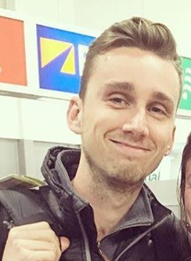
Jeremy Clarke is the founder of Simple Life Homes, a manufacturer of prefab-panelized homes for the high performance and passive house market. Previously, Jeremy explored a variety of careers including music production, aviation, renewable energy sales and construction. While discovering new interest’s, Jeremy discovered a common calling, and chose to focus on “green” construction. With a strong entrepreneurial spirit, Jeremy is currently focused on providing the building industry with a truly sustainable building system that utilizes carbon capturing materials and high performance assemblies to increase occupants health and reduce our impact on our environment by living within our carbon budget.

